***UPES PYTHON LAB ASSIGNMENT***

***EXPERIMENT 7&8***

***NAME – ANMOL YADAV***

***SAP ID – 500083814***

***BATCH – B8***

***QUESTION 1:***

Q1. Write a Python program to:

1. read a ﬁle.

2. add backslash (\) before every double quote in the ﬁle contents.

3. Write it to another file in the same folder.

4. Print the contents of both the files.

**Sol :**

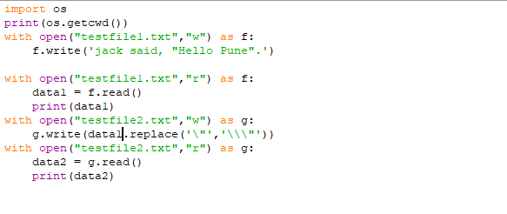

**Output:**

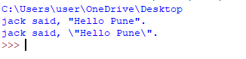

**QUESTION 2:**

Q2. Consider a ﬁle 'rhyme.txt' in D Drive with following text:

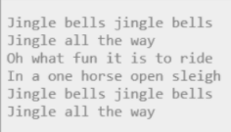

Write a Python program to count the words in the ﬁle using a dictionary (use space as a delimiter). Find unique words and the count of their occurrences (ignoring case). Write the output in another ﬁle "words.txt" at the same location.

**Sol:**

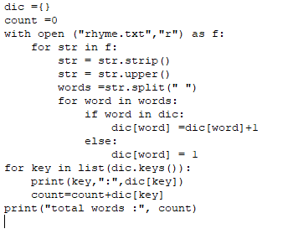

**Output:**

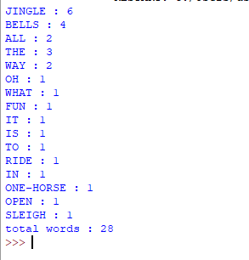

**QUESTION 3:**

Q3. Assume a file city.txt with details of 5 cities in given format (cityname  population(in lakhs) area(in sq KM) ):

Example:

Dehradun 5.78 308.20

Delhi 190 1484

……………

Open file city.txt and read to:

1. Display details of all cities
2. Display city names with population more than 10Lakhs

Display sum of areas of all cities

**SOL:**